Urinary bladder

Location
Anterior part of lesser pelvis
Behind pubic symphysis
In front of rectum in males
In front of uterus in females

Expansion into abdominal cavity
Empty bladder is completely pelvic
Distended bladder enlarges into the infraumbilical part of abdomen

Bladder distension
It is customary to evaluate the transabdominal pelvic ultrasonography with distended bladder. Distended bladder acts as an acoustic window
However, transvaginal ultrasonography can be equally effective in detecting pelvic organs in females, without compulsorily subjecting every patient for bladder distension
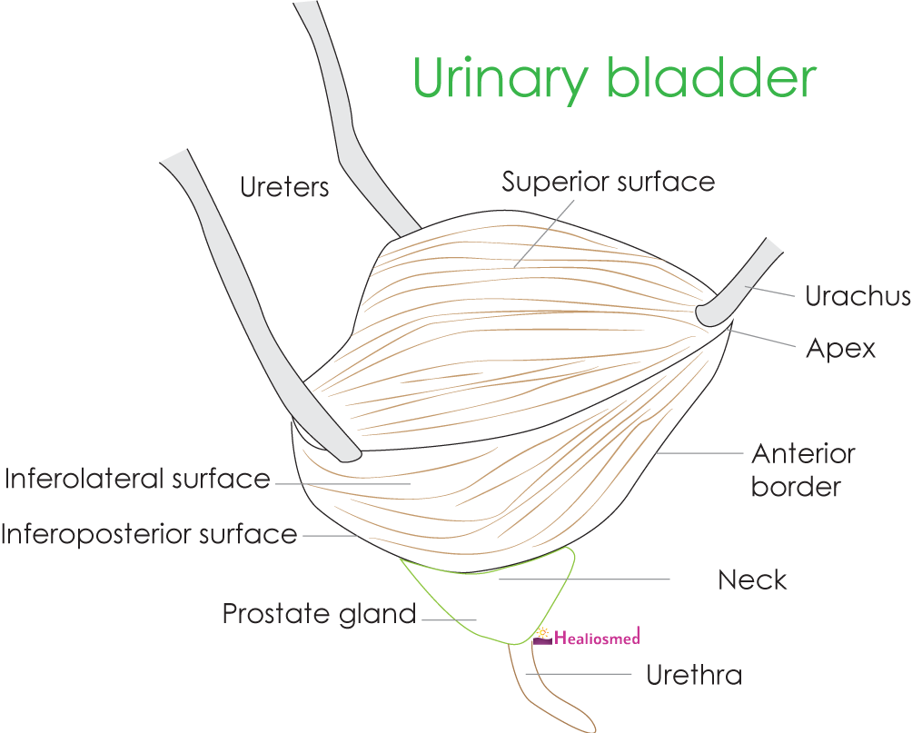

External features
- One superior surface
- Two inferolateral surfaces
- One inferoposterior surface (posterior, base)

Angles
Apex - where superior surface continues with inferolateral surfaces
Neck (inferior angle) - where two inferolateral surfaces meets the posterior surface
Two lateral angles - where ureters enters the bladder wall

Borders
Posterior
Anterior
2 lateral borders

Distended bladder is oval in shape
As the bladder distends, the distinction between surfaces and borders obscures.

Relations - Superior surface
Peritoneal cavity containing loops of ileum
Coils of ileum
Sigmoid colon
Uterus (in female)

Relations - Inferolateral surface
Retropubic space (of Retzius)
Puboprostatic ligament
Obturator internus and levator ani muscles

Relations - Posterior surface
Fascia of Denonvilliers'

In males
- Rectovescical pouch
- Vas deferens, seminal vesicles, ejaculatory duct

In females
- Vesicouterine pouch
- Cervix and upper part of vagina

Relations – Apex
Median umbilical ligament

Relations – Neck
In males - Prostate gland
In females - Urogenital diaphragm
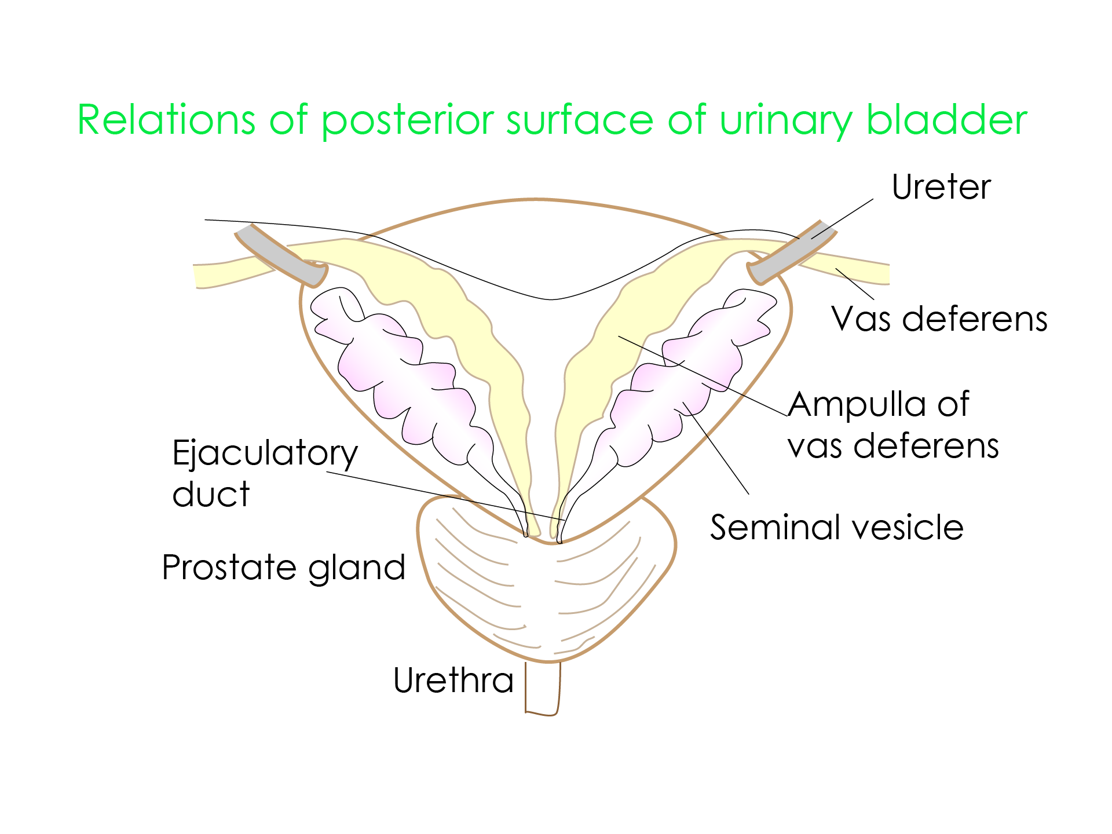

Seminal vesicle
Carnivores animals don't have seminal vesicles
Animals with prostate gland and seminal vesicles are herbivores

Supports of urinary bladder

Ligaments
- Two lateral ligaments
- Pair of Puboprostatic ligaments - medial and lateral
- Median umbilical ligament - remnant of urachus
- Posterior ligament

False ligaments
- Median umbilical fold - peritoneum over median umbilical ligament
- Two medial umbilical folds - periteneum over obliterated umbilical arteries
- Laterally - peritoneum over paravesical fossae
- Posteriorly sacrogenital fold - peritoneum from bladder to sacrum encircling rectum

Interior of bladder
- Trigone of bladder
- Irregular mucosal infoldings
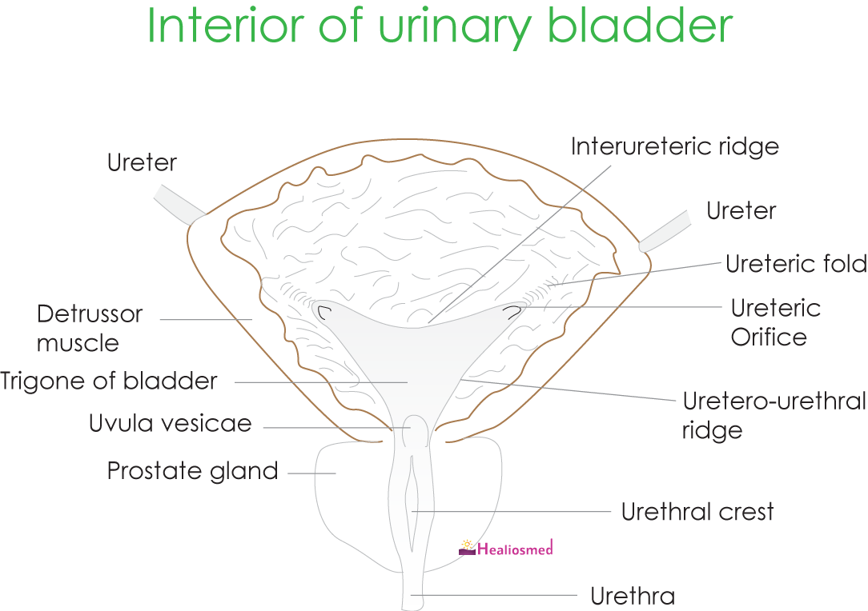

Trigone of bladder
Mucosa is firmly bound to underlying muscular coat - makes trigone smooth

Trigone of bladder – boundaries
Interureteric ridge on top
Uretero - urethral ridge on either side

Trigone of bladder – development
From absorbed portion of caudal end of mesonephric duct
Mesonephric duct is mesodermal in origin
Rest of the bladder develops from primitive urogenital sinus, endodermal origin

Early in development, trigone of bladder is mesodermal in origin. Later - the endodermal epithelium forms the mucosa of trigone of bladder

This concept is recently challenged. There is limited evidence for the same. Using cre-lox recombination lineage system in mice, trigone of bladder has same origin as that of bladder. Ref: (Development 2007 134: 3763-3769; doi: 10.1242/dev.011270)

Trigone of bladder - wall architecture
Detrussor muscle in the rest of bladder is arranged in whorls and spirals in a single layer
In trigone of bladder detrussor has well defined three layers - inner longitudinal, middle circular, outer longitudinal
Additionally, the trigone has muscles essentially continuing with ureters.
This is divided into two layers.
Superficial layer
- Longitudinal fibres of the intravesical ureter at the ureterovesical orificce that spread into the base of urinary bladder
Deep layer -
- Continuation of the fibromuscular tissue around the terminal part of the ureters (sheath of Waldeyer)
Submucosa is not demonstrable in trigone of bladder. Mucosa is directly adherent to muscular coat

Trigone of bladder – physiology
It is relatively indistensible.
The exact function of the trigone in the act of micturition is not yet known.
(Ref: Shafik A, Role of trigone in micturition. J Endourol. 1998 Jun;12(3):273-7)

Urological divisions of bladder
- Base (posterior wall)
- Lateral walls
- Dome
- Apex
- Neck
- Trigone

Arterial supply
- Superior vesical artery
- Inferior vesical artery
- Smaller contribution from obturator artery, inferior gluteal artery
- In females - uterine artery, vaginal arteries

Innervation of bladder
The central nervous regulation of the lower urinary tract is mediated by simple on-off switching circuits in the brain and spinal cord that are under voluntary control

Innervation – Sympathetic
- Intermediolateral cell column at T11-L2 or at L1 and L2
- Lumbar splanchnic nerves
- Superior hypogastric plexus
- Right and left hypogastric nerves
- Right and left inferior pelvic hypogastric plexuses
- Autonomic innervation of the superficial trigone musculature and the urethra

Innervation – Parasympathetic
- Intermediate gray of the spinal cord at S2, S3, and S4
- Pelvic splanchnic nerves (or nervi erigentes)
- Right and left pelvic plexuses
- Preganglionic fibers ultimately synapse in ganglia in the pelvic connective tissues or upon, or within, the walls of the pelvic organs
- Provide motor stimulation for the detrusor musculature of the bladder

Innervation - sensory fibres
- Sacral part of the spinal cord
- Pelvic splanchnic nerves
- Sympathetic pathways up through the pelvic, hypogastric, and preaortic plexuses to reach the sympathetic chains
- Duality of the pathways for pain
- Presacral neurectomy does not materially reduce vesical pain
- Bilateral anterolateral cordotomy may be required

Innervation - somatic fibres
- Sacral cord at S2, S3, S4
- Pudendal nerve
- Innervation of the periurethral striated sphincteric apparatus that voluntarily stops urination
- Compressor urethrae muscle and the sphincter urethrae of the urogenital diaphragm and the bulbospongiosus muscle of the superficial perineal compartment

Innervation - cortical representation
- Paracentral lobule
- Evoke bladder contraction

Micturition

Act of voiding
Fundamentally a spinal reflex facilitated and inhibited by higher centers

Storage reflex
- Slow filling of bladder, produce slow distenstion of bladder
- This stimulates sympathetic outflow in
  - Hypogastric nerves - to bladder outlet
  - Pudendal nerves - to external urethral sphincter
  - Inhibits contraction of detrussor muscle
- Rostral pontine storage center - increase urethral storage activity

Voiding reflex
- Spinobulbospinal reflex pathways - pass through the pontine micturition centre
- Stimulates the parasympathetic outflow to the bladder and to urethral smooth muscle
- Inhibits the sympathetic and pudendal outflow to the urethral outlet
  - Periaqueductal grey relay impulses before reaching the pontine micturition centre

Vesicoureteral reflux
Factors preventing vesicoureteral reflux
- Oblique course of ureters within the bladder musculature and submucosally
- Ureteral muscles blends with detrusor muscles posteriorly
- These factors result in valve like mechanism around the intramural part of ureter
This prevents reflux of urine back into the ureters during normal filling and moreso during micturition
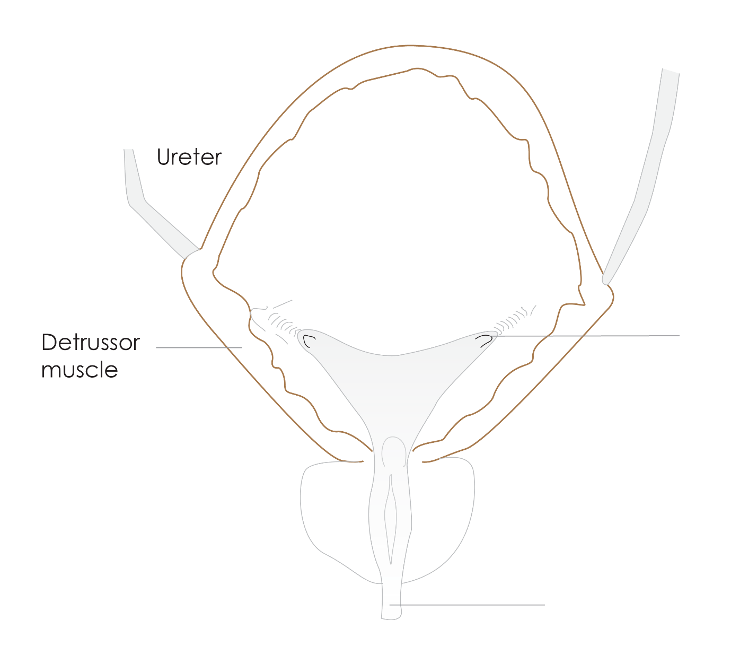
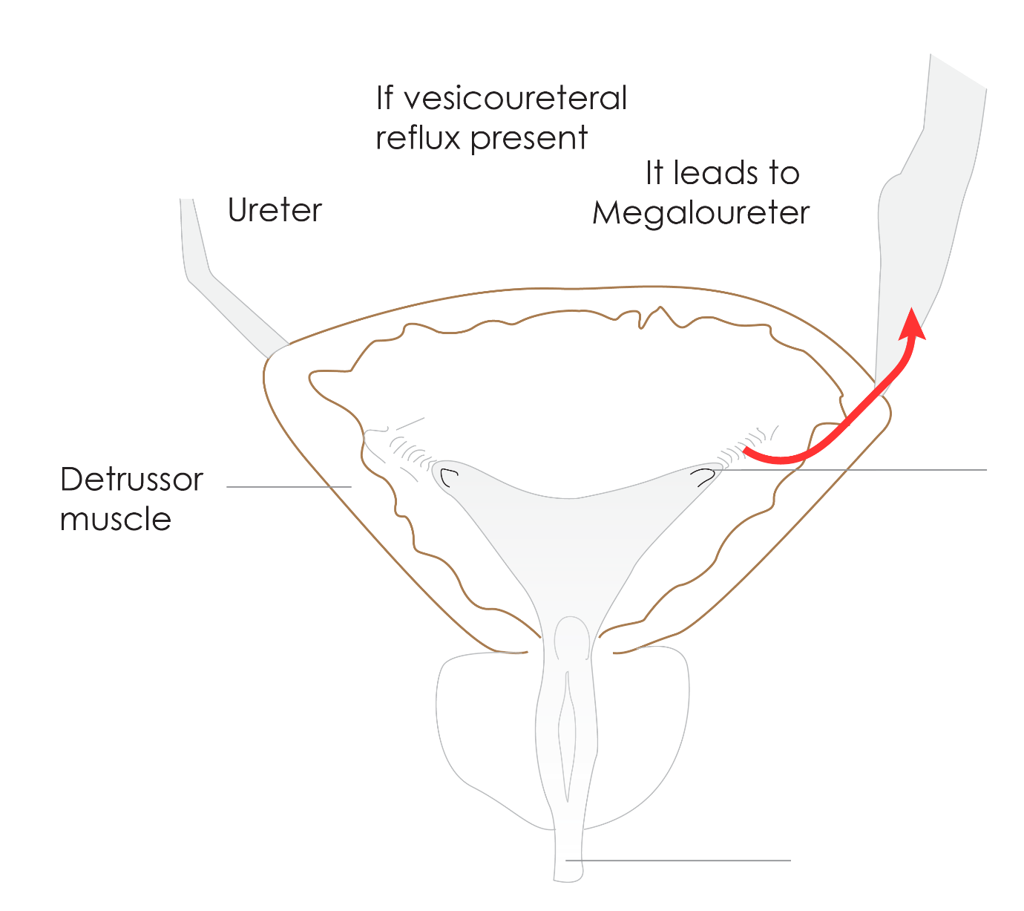

Effects of vesicoureteral reflux
This leads to Megaloureter, hydroureter later may cause hydronephrosis

